Paste command in Linux with examples

  - Paste command is one of the useful commands in Unix or Linux operating system.
  - It is used to join files horizontally (parallel merging) by outputting lines consisting of lines from each file specified, separated by tab as delimiter, to the standard output.
- When no file is specified, or put dash ("-") instead of file name, paste reads from standard input and gives output as it is until a interrupt command [Ctrl-c] is given.
Syntax:

paste [OPTION]... [FILES]...

Let us consider three files having name state, capital and number. state and capital file contains 5 names of the Indian states and capitals respectively. number file contains 5 numbers.

$ cat number
1
2
3
4
5

$ cat state Arunachal Pradesh Assam
Andhra Pradesh Bihar
Chhattisgrah

$ cat capital Itanagar Dispur Hyderabad Patna
Raipur

Without any option paste merges the files in parallel. The paste command writes corresponding lines from the files with tab as a deliminator on the terminal.

$ paste number state capital
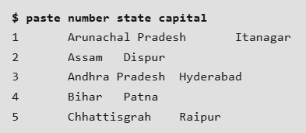

In the above command three files are merges by paste command.

Options: 1. -d ( delimiter) : Paste command uses the tab delimiter by default for merging the files.

The delimiter can be changed to any other character by using the -d option.
If more than one character is specified as delimiter then paste uses it in a circular fashion for each file line separation.

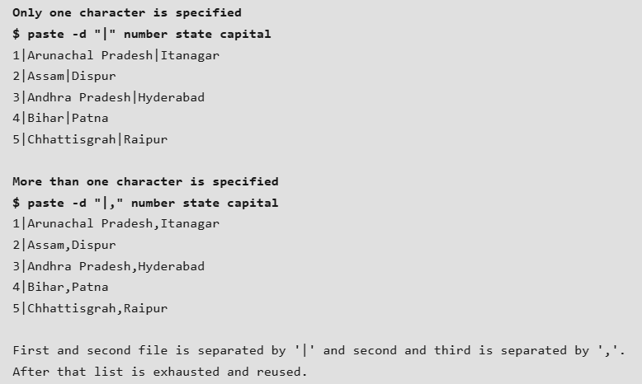

2. -s ( serial) : We can merge the files in sequentially manner using the - s option.
It reads all the lines from a single file and merges all these lines into a single line with each line separated by tab.
And these single lines are separated by newline.

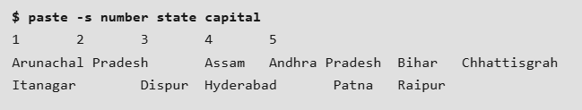

In the above command, first it reads data from number file and merge them into single line with each line separated by tab. After that newline character is introduced and reading from next file i.e. state starts and process repeats again till all files are read.

Combination of -d and -s:
The following example shows how to specify a delimiter for sequential merging of files:

$ paste -s -d ":" number state capital
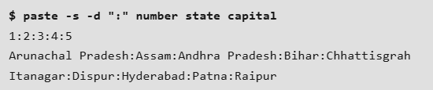

- --version: This option is used to display the version of paste which is currently running on your system.
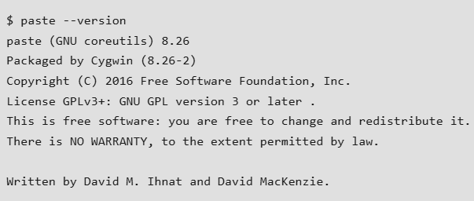

Applications of Paste Command
- Combining N consecutive lines: The paste command can also be used to merge N consecutive lines from a file into a single line.
Here N can be specified by specifying number hyphens(-) after paste.

With 2 hyphens
$ cat capital | paste - -

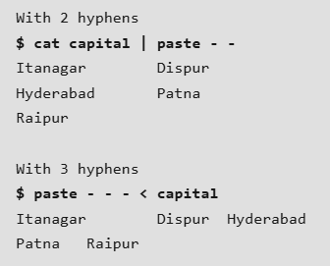

Combination with other commands:
Even though paste require at least two files for concatenating lines, but data from one file can be given from shell.
Like in our example below, cut command is used with - f option for cutting out first field of state file and output is pipelined with paste command having one file name and instead of second file name hyphen is specified.
Note: If hyphen is not specified then input from shell is not pasted.

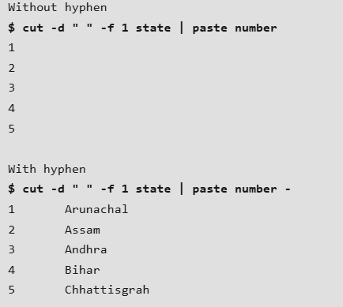

Ordering of pasting can be changed by altering the location of hyphen:
